**Petunjuk Programming Arduino :**

1. Unduh Arduino IDE

Pilih versi windows / mac os / linux.



2. Rangkaian di arduino dan project board (sumber gambar: google.com).

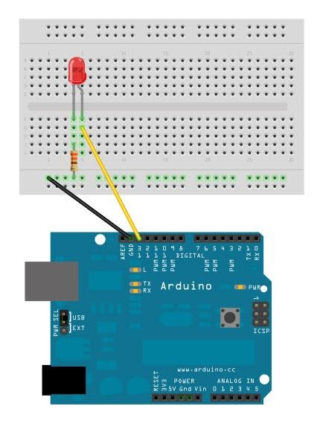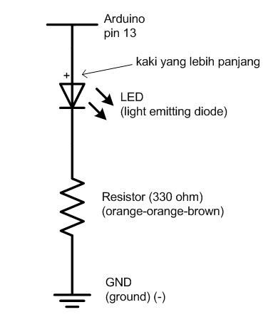

Keterangan:

1. Pin di arduino yang digunakan nomor 13 dan GND

2. Besaran resistor 330 ohm

3. LED

3. Melakukan pemrograman pertama di Arduino IDE

a. Colokkan kabel dari arduino ke USB di komputer, lalu buka **computer > device manager** (**Control Panel\System and Security\System**)untuk melihat port yang digunakan.

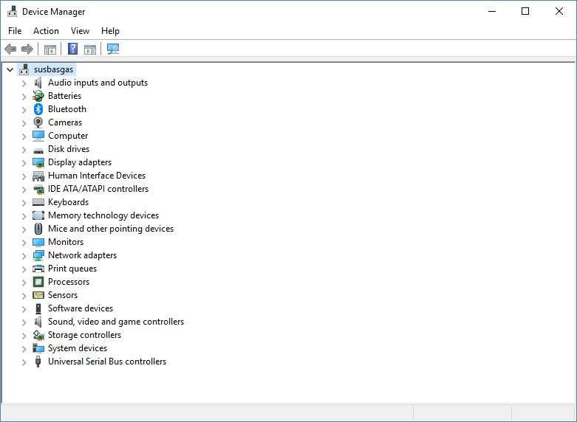

b. Buka Arduino IDE

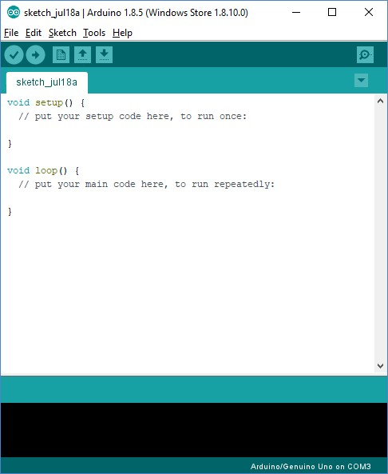

c. Tuliskan program untuk membuat LED menjadi berkedip. const int pinn=12;

void setup() {

// put your setup code here, to run once:

pinMode(pinn,OUTPUT);

}

void loop() {

// put your main code here, to run repeatedly:

digitalWrite(pinn,HIGH);

delay(1000);

digitalWrite(pinn,LOW);

delay(1000);

}

Keterangan:

1. **Case sensitive** artinya huruf kecil dan huruf besar sangat mempengaruhi dari keberhasilan atau kegagalan di dalam menulis program.

2. **const int pinn=12;** pinn adalah variabel dengan tipe data integer dan

digunakan untuk menyimpan angka. Angka 12 menunjukkan pin yang digunakan di arduino. Jika melihat rangkaian di atas, maka pin yang digunakan adalah 13. Jadi angka 12 sebaiknya diubah ke angka 13 atau ke port yang sedang digunakan saat ini.

3. **digitalWrite(pinn,HIGH);** HIGH digunakan untuk menyalakan LED

4. **digitalWrite(pinn,LOW);** LOW digunakan untuk mematikan LED

4. Melakukan *running* program arduino LED berkedip.

a. Setting board arduino (tools > board > arduino Genuino Uno)

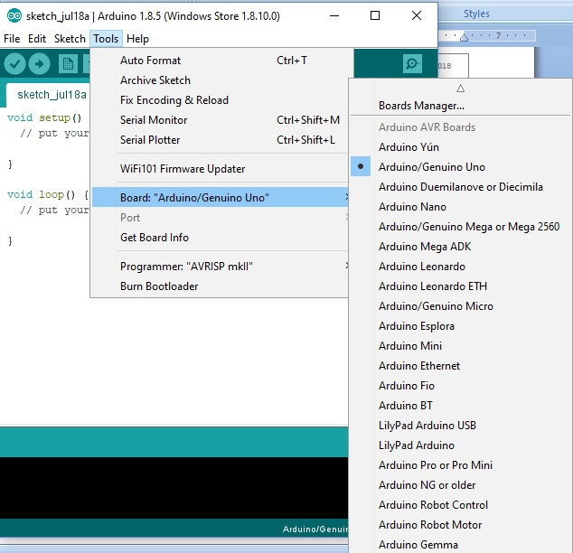

b. Setting port

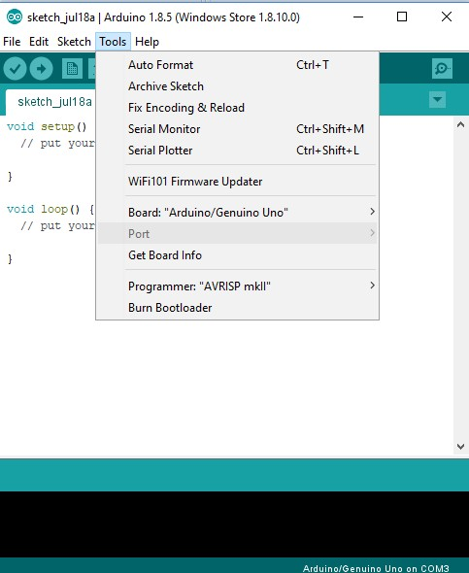

c. Compile program. Memeriksa dan memastikan baris program tidak terjadi kesalahan. Tunggu sebentar untuk melihat hasil compile yang menyatakan program tidak terdapat error atau program masih terdapat error.



d. Upload ke Arduino. Digunakan untuk mengirimkan program ke Arduino yang digunakan.



e. Perhatikan LED menyala secara berkedip.

**Pinout Arduino Multifunction Board**

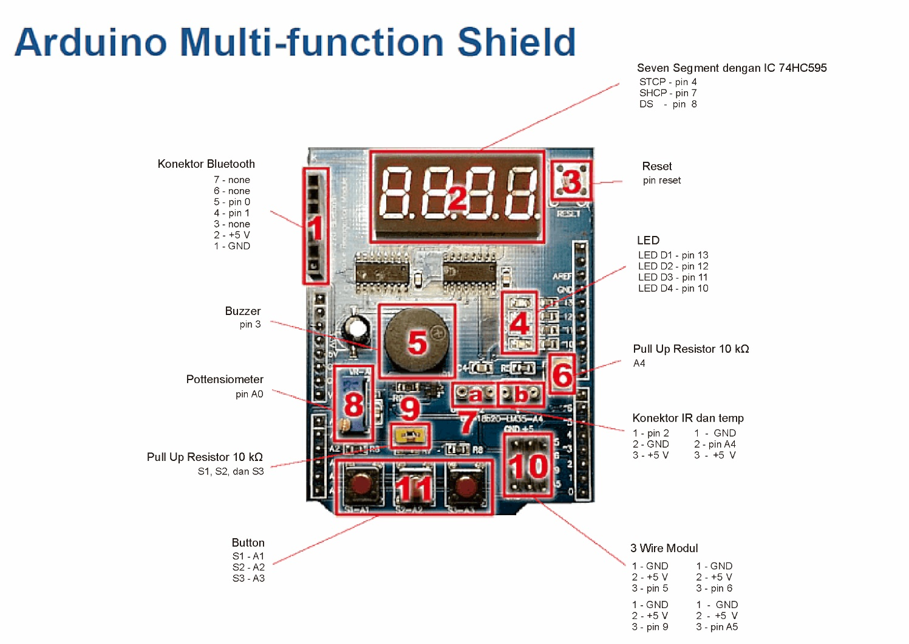

**Schematic Arduino Multifunction Board**

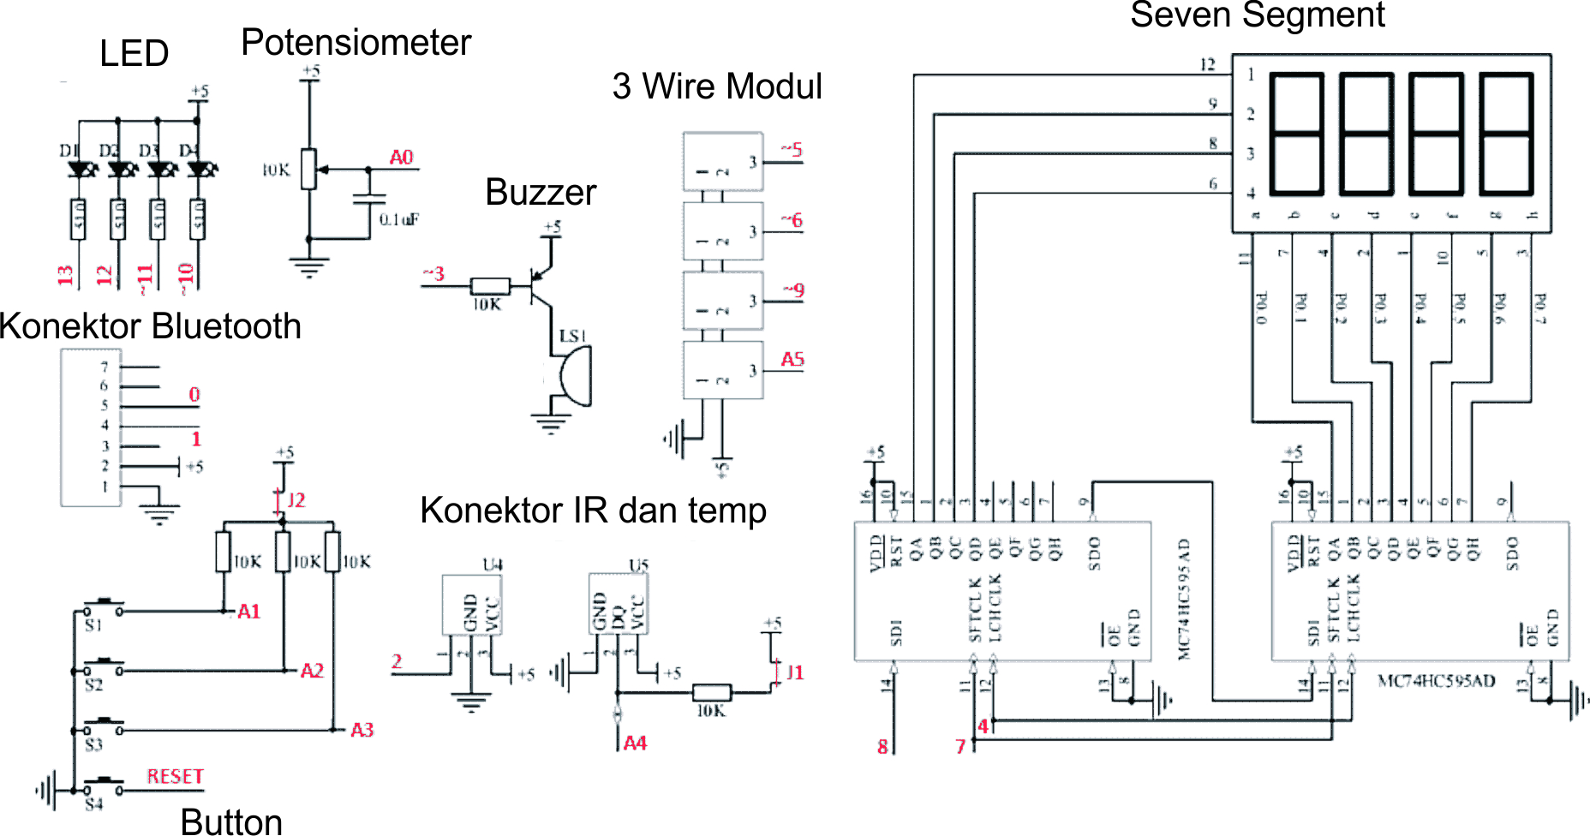

**Syntax Arduino**

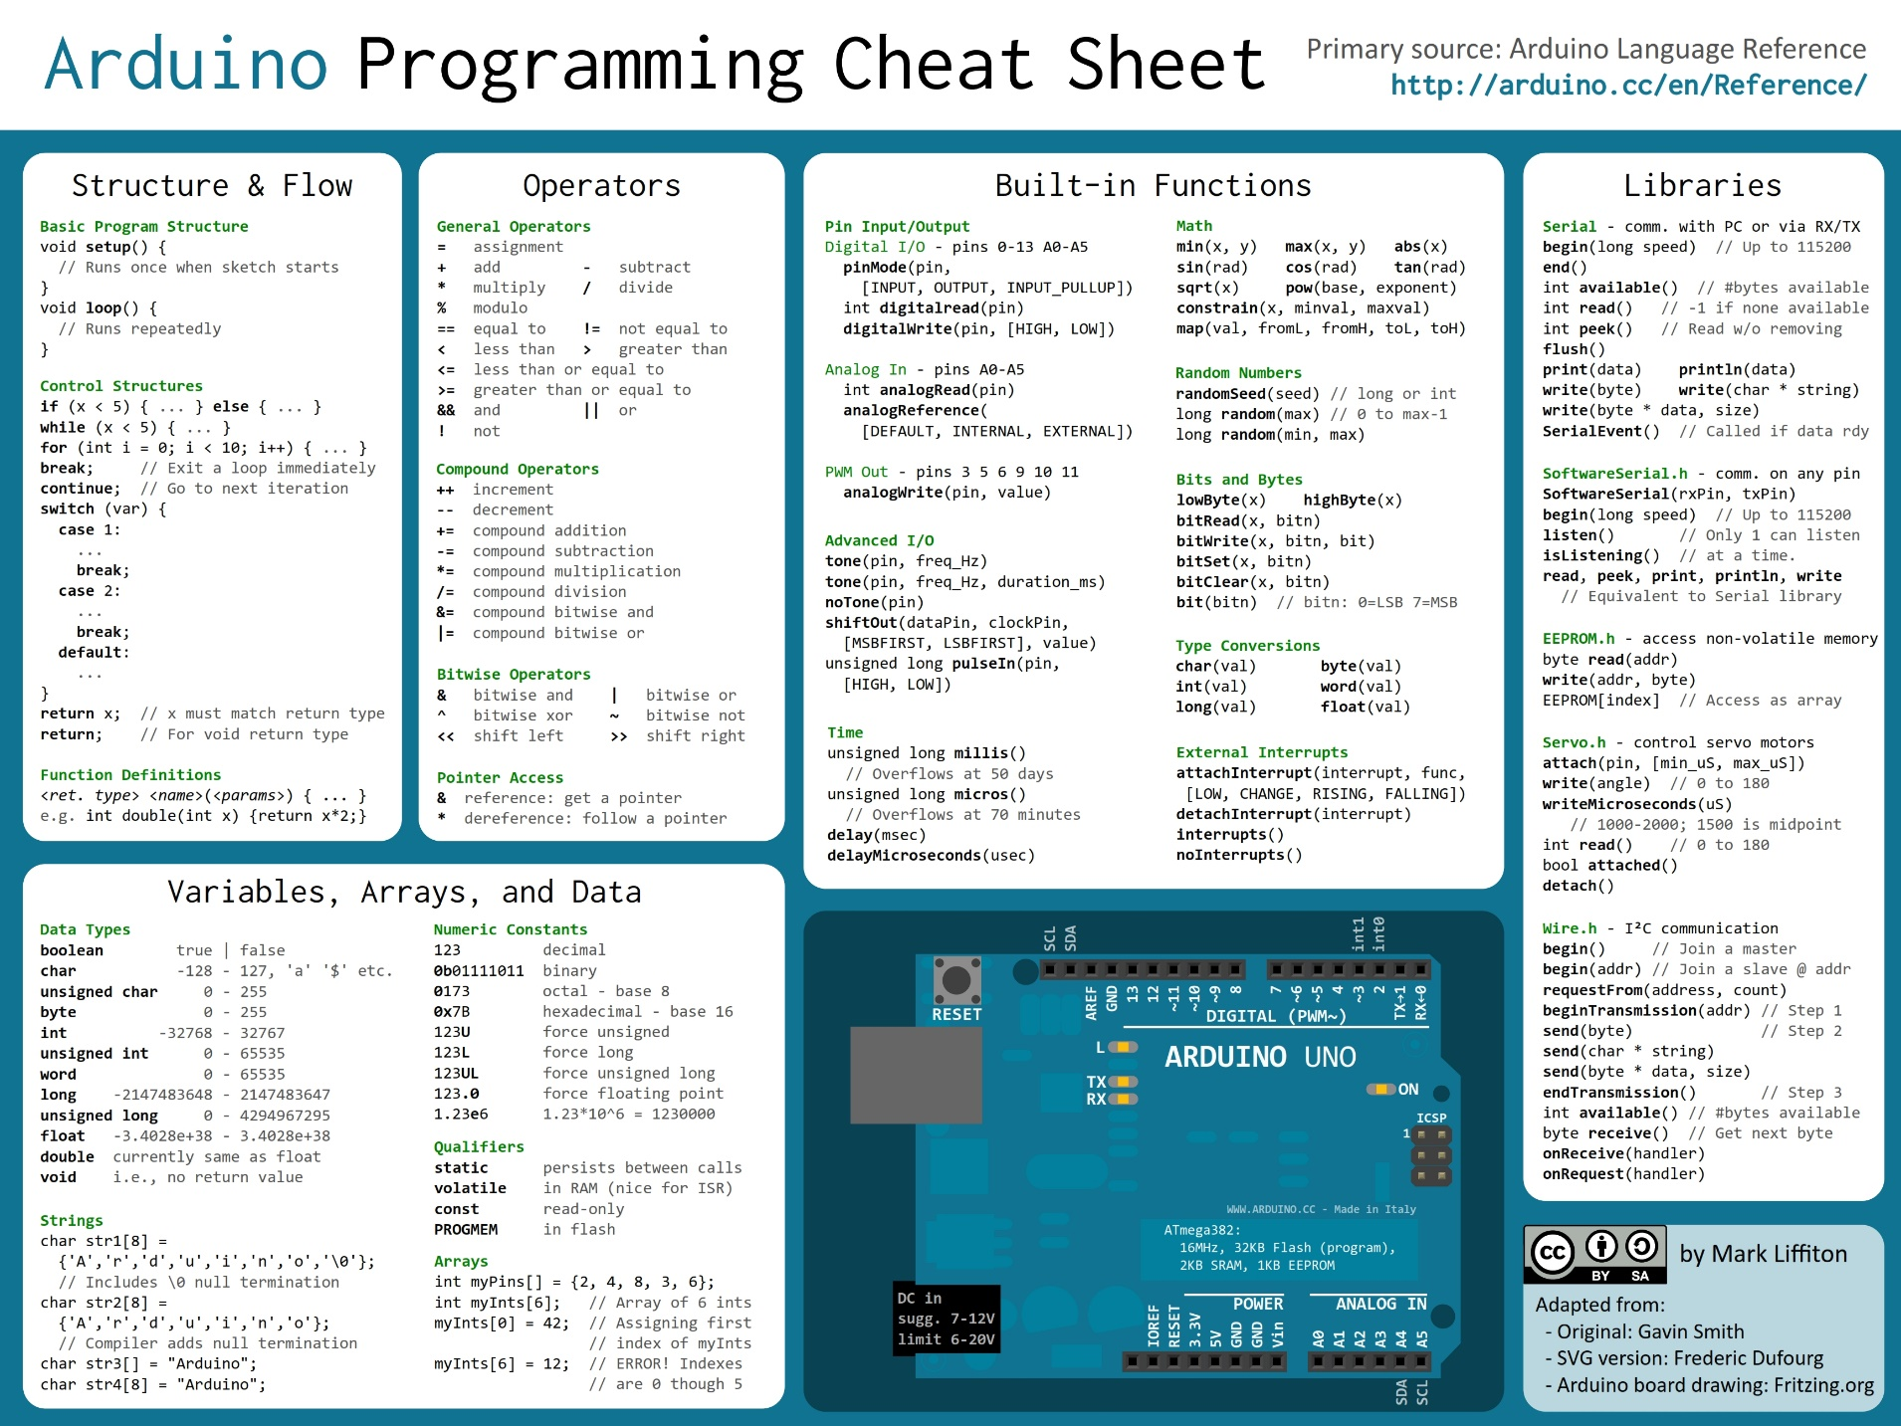

**Contoh Arduino Multifunction**

1. LED Blinking

#define LED_D4 10

void setup() {

pinMode(LED_D4,OUTPUT);

}

void loop() {

digitalWrite(LED_D4,HIGH);

delay(1000);

digitalWrite(LED_D4,LOW);

delay(1000);

}

1. Buzzer Delay

#define Buzzer 3

void setup() {

pinMode(Buzzer,OUTPUT);

}

void loop() {

digitalWrite(Buzzer,HIGH);

delay(1000);

digitalWrite(Buzzer,LOW);

delay(1000);

}

1. LED Combination

int LED[4]={13,12,11,10};

int i;

void setup() {

for(i=0;i<=3;i++)

pinMode(LED[i],OUTPUT);

}

void loop() {

for(i=0;i<=3;i++){

digitalWrite(LED[i],HIGH);

delay(1000);

}

for(i=0;i<=3;i++){

digitalWrite(LED[i],LOW);

delay(1000);

}

}

1. Switch Combination

#define Buzzer 3

#define LED_D4 10

#define Sw_1 A1

#define Sw_2 A2

#define Sw_3 A3

void setup() {

pinMode(Buzzer,OUTPUT);

pinMode(LED_D4,OUTPUT);

pinMode(Sw_1,INPUT);

pinMode(Sw_2,INPUT);

pinMode(Sw_3,INPUT);

digitalWrite(LED_D4,HIGH);

digitalWrite(Buzzer,HIGH);

}

void loop() {

if(digitalRead(Sw_1)==0){

digitalWrite(LED_D4,LOW);

}else if(digitalRead(Sw_2)==0){

digitalWrite(LED_D4,HIGH);

}else if(digitalRead(Sw_3)==0){

digitalWrite(Buzzer,LOW);

}else if(digitalRead(Sw_3)==1){

digitalWrite(Buzzer,HIGH);

}

}

1. Membaca Potensiometer dengan Serial Monitor

#define Potensio A0

void setup() {

Serial.begin(9600);

pinMode(Potensio,INPUT);

}

void loop() {

Serial.println(analogRead(Potensio));

delay(100);

}

1. PWM

#define PinPWM 5

void setup() {

}

void loop() {

for (int fadeValue = 0 ; fadeValue <= 255; fadeValue += 5) {

analogWrite(PinPWM, fadeValue);

delay(30);

}

for (int fadeValue = 255 ; fadeValue >= 0; fadeValue -= 5) {

analogWrite(PinPWM, fadeValue);

delay(30);

}

}

1. Servo Motor

#include <Servo.h>

#define PinServo 5

Servo myservo;

int pos = 0;

void setup() {

myservo.attach(PinServo);

}

void loop() {

for (pos = 0; pos <= 180; pos += 1) {

myservo.write(pos);

delay(15);

}

for (pos = 180; pos >= 0; pos -= 1) {

myservo.write(pos);

delay(15);

}

}

1. Library Timer dengan Serial Monitor

#include <TimerOne.h>

void setup() {

Serial.begin(9600);

Timer1.initialize(1000000);

Timer1.attachInterrupt(timerInt);

}

int i;

void loop() {

Serial.println(i);

delay(2000);

}

void timerInt(){

i++;

}

1. Seven Segment

#define Potensio A0

#define S_STCP 4

#define S_SHCP 7

#define S_DS 8

byte Segment_Map[10]={0xC0,0xF9,0xA4,0xB0,0x99,0x92,0x82,0xF8,0x80,0x90};

byte Segment_Digit[4]={0xF8,0xF4,0xF2,0xF1};

void setup() {

Serial.begin(9600);

pinMode(Potensio,INPUT);

pinMode(S_STCP,OUTPUT);

pinMode(S_SHCP,OUTPUT);

pinMode(S_DS,OUTPUT);

}

int baca;

int digit_baca;

int digit_hasil;

long TS_Pot;

void loop() {

digitalWrite(S_STCP,LOW);

shiftOut(S_DS,S_SHCP,MSBFIRST,Segment_Map[2]);

shiftOut(S_DS,S_SHCP,MSBFIRST,Segment_Digit[3]);

digitalWrite(S_STCP,HIGH);

delay(1);

digitalWrite(S_STCP,LOW);

shiftOut(S_DS,S_SHCP,MSBFIRST,Segment_Map[0]);

shiftOut(S_DS,S_SHCP,MSBFIRST,Segment_Digit[2]);

digitalWrite(S_STCP,HIGH);

delay(1);

digitalWrite(S_STCP,LOW);

shiftOut(S_DS,S_SHCP,MSBFIRST,Segment_Map[1]);

shiftOut(S_DS,S_SHCP,MSBFIRST,Segment_Digit[1]);

digitalWrite(S_STCP,HIGH);

delay(1);

digitalWrite(S_STCP,LOW);

shiftOut(S_DS,S_SHCP,MSBFIRST,Segment_Map[8]);

shiftOut(S_DS,S_SHCP,MSBFIRST,Segment_Digit[0]);

digitalWrite(S_STCP,HIGH);

delay(1);

}

1. Potensiometer dengan Tampilan Seven Segment

#define Potensio A0

#define S_STCP 4

#define S_SHCP 7

#define S_DS 8

byte Segment_Map[10]={0xC0,0xF9,0xA4,0xB0,0x99,0x92,0x82,0xF8,0x80,0x90};

byte Segment_Digit[4]={0xF8,0xF4,0xF2,0xF1};

void setup() {

Serial.begin(9600);

pinMode(Potensio,INPUT);

pinMode(S_STCP,OUTPUT);

pinMode(S_SHCP,OUTPUT);

pinMode(S_DS,OUTPUT);

}

int baca;

int digit_baca;

int digit_hasil;

long TS_Pot;

void loop() {

if(millis()-TS_Pot>=100){

baca=analogRead(Potensio);

TS_Pot=millis();

}

digit_baca=baca;

for(int i=0;i<=3;i++){

digit_hasil=digit_baca%10;

digitalWrite(S_STCP,LOW);

shiftOut(S_DS,S_SHCP,MSBFIRST,Segment_Map[digit_hasil]);

shiftOut(S_DS,S_SHCP,MSBFIRST,Segment_Digit[i]);

digitalWrite(S_STCP,HIGH);

digit_baca/=10;

}

delay(1);

}

1. Seven Segmen Timer

#include <TimerOne.h>

#define S_STCP 4

#define S_SHCP 7

#define S_DS 8

byte Segment_Map[10]={0xC0,0xF9,0xA4,0xB0,0x99,0x92,0x82,0xF8,0x80,0x90};

byte Segment_Digit[4]={0xF8,0xF4,0xF2,0xF1};

void setup() {

pinMode(S_STCP,OUTPUT);

pinMode(S_SHCP,OUTPUT);

pinMode(S_DS,OUTPUT);

Timer3.initialize(1000000);

Timer3.attachInterrupt(timerInt);

}

int waktu[4];

void loop() {

for(int i=0;i<=3;i++){

digitalWrite(S_STCP,LOW);

shiftOut(S_DS,S_SHCP,MSBFIRST,Segment_Map[waktu[i]]);

shiftOut(S_DS,S_SHCP,MSBFIRST,Segment_Digit[i]);

digitalWrite(S_STCP,HIGH);

}

delay(1);

}

void timerInt(){

waktu[0]++;

if(waktu[0]>=10){

waktu[0]=0;

waktu[1]++;

}

if(waktu[1]>=10){

waktu[1]=0;

waktu[2]++;

}

if(waktu[2]>=10){

waktu[2]=0;

waktu[3]++;

}

if(waktu[3]>=10){

waktu[0]=0;

waktu[1]=0;

waktu[2]=0;

waktu[3]=0;

}

}

1. Potensiometer dengan Servo Motor

#include <Servo.h>

#define Potensio A0

#define S_STCP 4

#define S_SHCP 7

#define S_DS 8

#define PinServo 5

byte Segment_Map[10]={0xC0,0xF9,0xA4,0xB0,0x99,0x92,0x82,0xF8,0x80,0x90};

byte Segment_Digit[4]={0xF8,0xF4,0xF2,0xF1};

Servo Svm;

void setup() {

Serial.begin(9600);

pinMode(Potensio,INPUT);

pinMode(S_STCP,OUTPUT);

pinMode(S_SHCP,OUTPUT);

pinMode(S_DS,OUTPUT);

Svm.attach(PinServo);

}

int baca;

int digit_baca;

int digit_hasil;

long TS_Pot;

void loop() {

if(millis()-TS_Pot>=100){

baca=map(analogRead(Potensio),0,1023,0,180);

TS_Pot=millis();

Svm.write(baca);

}

digit_baca=baca;

for(int i=0;i<=3;i++){

digit_hasil=digit_baca%10;

digitalWrite(S_STCP,LOW);

shiftOut(S_DS,S_SHCP,MSBFIRST,Segment_Map[digit_hasil]);

shiftOut(S_DS,S_SHCP,MSBFIRST,Segment_Digit[i]);

digitalWrite(S_STCP,HIGH);

digit_baca/=10;

}

delay(1);

}